A
Real-Time Research Project On
Time aware Health recommendation system
(Submitted in partial fulfillment of the requirements for the award of Degree)

BACHELOR OF TECHNOLOGY
In

COMPUTER SCIENCE AND ENGINEERING
By

Y. Abhinav (247R1A05Z0) B. Charan Sai (247R1A05T3)
P. Prashanth Babu (247R1A05X6)

Under the Guidance of

Dr. B. Laxmaiah
(Associate Professor)


DEPARTMENT OF COMPUTER SCIENCE AND ENGINEERING
CMR TECHNICAL CAMPUS
UGC AUTONOMOUS
(Accredited by NAAC, NBA, Permanently Affiliated to JNTUH, Approved by AICTE, New Delhi)
Recognized Under Section 2(f) & 12(B) of the UGCAct.1956, Kandlakoya (V), Medchal Road, Hyderabad-501401.
April, 2026.

DEPARTMENT OF COMPUTER SCIENCE AND ENGINEERING


CERTIFICATE

This is to certify that the project entitled “Time aware health recommendation system” being submitted by Y. Sai Abhinav (247R1A05Z0), B. Charan Sai (247R1A05T3) & P. Prashanth (247R1A05X6) in partial fulfillment of the requirements for the award of the degree of B.Tech in Computer Science and Engineering to the Jawaharlal Nehru Technological University Hyderabad, during the year 2025-26.

The results embodied in this thesis have not been submitted to any other University or Institute for the award of any degree or diploma.

Dr. B. Laxmaiah Dr. Nuthanakanti Bhaskar Professor HoD
INTERNAL GUIDE

ACKNOWLEDGEMENT
We take this opportunity to express our gratitude to the people who have been instrumental in the successful completion of this project, we take this opportunity to express our profound gratitude and deep regard to our guide Dr. B. Laxhmaiah, Professor for his exemplary guidance, monitoring and constant encouragement throughout the project work. The blessing, help and guidance given by him shall carry us a long way in the journey of life on which we are about to embark.

We take this opportunity to extend our heartfelt appreciation to the Project Review Committee (PRC) Coordinators—Dr. J. Narasimharao, Mrs. V. Neeraja, Mrs. G. Swarnalatha and Mrs. L. Swathi —for their unwavering support, insightful guidance, and valuable inputs, which played a crucial role in steering this project through its various stages.

Our sincere appreciation also goes to Dr. Nuthanakanti Bhaskar, Head, for his encouragement and continuous support in ensuring the successful completion of our project.
We are deeply grateful to Dr. A. Raji Reddy, Director, for his cooperation throughout the course of this project. Additionally, we extend our profound gratitude to Sri. Ch. Gopal Reddy, Chairman, Smt. C. Vasantha Latha, Secretary and Sri. C. Abhinav Reddy, Vice-Chairman, for fostering an excellent infrastructure and a conducive learning environment that greatly contributed to our progress.

We also acknowledge and appreciate the guidance and assistance provided by the faculty and staff of CMR Technical Campus, whose contributions have been invaluable in bringing this project to fruition.

Lastly, we sincerely thank our families for their unwavering support and encouragement. We also extend our gratitude to the teaching and non-teaching staff of CMR Technical Campus for their guidance and assistance. Their contributions, along with the support of everyone who helped directly or indirectly, have been invaluable in the successful completion of this project.

Y. Sai Abhinav (247R1A05Z0)
P. Prashanth babu(247R1A05X6)
B. Charan Sai(247R1A05T3)

VISION AND MISSION

INSTITUTE VISION:
To Impart quality education in serene atmosphere thus strive for excellence in Technology and Research.

INSTITUTE MISSION:
- To create state of art facilities for effective Teaching- Learning Process.

- Pursue and Disseminate Knowledge based research to meet the needs of Industry & Society.

- Infuse Professional, Ethical and Societal values among Learning Community.

DEPARTMENT VISION:
To provide quality education and a conducive learning environment in computer engineering that foster critical thinking, creativity, and practical problem-solving skills.

DEPARTMENT MISSION:
- To educate the students in fundamental principles of computing and induce the skills needed to solve practical problems.

- To provide State-of-the-art computing laboratory facilities to promote
industry institute interaction to enhance student’s practical knowledge.

- To inculcate self-learning abilities, team spirit, and professional ethics among the students to serve society.

ABSTRACT

This project is titled as “Time aware health recommendation system”. A Time-Aware Health Recommendation System is an intelligent application designed to suggest appropriate food choices to users by considering the time of day, user preferences, dietary habits, and contextual factors. The primary goal of this project is to improve traditional food recommendation systems by incorporating temporal awareness, meaning the system understands that people prefer different types of food at different times such as breakfast, lunch, snacks, or dinner. For example, a user might prefer light and healthy meals like fruits or oatmeal in the morning, while heavier meals such as rice dishes or pasta may be recommended during lunch or dinner hours. The system typically collects data from users including their previous food selections, ratings, nutritional preferences, and sometimes health-related information. Using machine learning techniques, recommendation algorithms (such as collaborative filtering or content-based filtering), and time-based context analysis, the system analyzes patterns in user behavior to provide personalized suggestions at the most suitable time. Additionally, the project may integrate features like seasonal food recommendations, calorie tracking, and diet-specific suggestions for people following vegetarian, vegan, or medical diets. A user-friendly interface allows users to interact with the system easily, receive meal suggestions, and provide feedback that continuously improves recommendation accuracy. Overall, the Time-Aware Food Recommendation System enhances user convenience, supports healthier eating habits, and demonstrates how contextual information such as time can significantly improve the relevance and effectiveness of recommendation technologies.

LIST OF FIGURES

FIGURE NO FIGURE NAME PAGE NO

Figure 3.1
System architecture of the time 21
aware health recommendation
system

Figure 3.2

Use case diagram for
time aware health recommendation 24
system

Figure 5.1
Figure 5.2

User login page for time aware 45
health recommendation system
User home page for time aware 45
health recommendation system

Figure 5.3
User added medication page for
time aware health recommendation 46
system

Figure 5.4
User schedule page for time aware
health recommendation system 46

Figure 5.5
Backup and recovery page for time aware health recommendation system

Figure 5.6
Application settings for time aware health recommendation system

TABLE OF CONTENTS
S.NO | CONTENT | PAGE NO
1 | ABSTRACT | i
2 | 1. INTRODUCTION | 1
 | 1.1 Project Purpose | 4
 | 1.2 Project Features | 4
3 | 2. LITERATURE SURVEY | 6
 | 2.1 Review of Related Work | 8
 | 2.2 Definition of Problem Statement | 9
 | 2.3 Existing System | 10
 | 2.4 Proposed System | 12
 | 2.5 Advantages | 14
 | 2.6 Objectives | 16
 | 2.7 Software Requirements | 18
 | 2.8 Hardware Requirements | 18
4 | 3. SYSTEM ARCHITECTURE AND DESIGN | 20
 | 3.1 UML Diagrams | 22
 | 3.1.1 Use Case Diagram | 23
 | 3.1.2 Activity Flow Diagram | 24
 | 3.2 Modules | 25
 | 3.2.1 User Interface Module | 26
 | 3.2.2 Medicine Management Module | 26
 | 3.2.3 Reminder Notification Module | 27
 | 3.2.4 Settings Module | 27
 | 3.3 Methodology | 28
 | 3.4 Dataset Description | 29
5 | 4. IMPLEMENTATION | 32
 | 4.1 Algorithms Used | 33
 | 4.2 Implementation | 34
6 | 5. RESULTS AND DISCUSSION | 42
 | 5.1 Experimental Results | 43
7 | 6. VALIDATION | 48
 | 6.1 Validation | 49+
8 | 7. CONCLUSION | 50
 | 7.1 Conclusion | 51
 | 7.2 Future Work | 52

Introduction

Introduction

The Medicine Intake Project is a modern web-based application designed to help users effectively manage their daily medication schedules and improve adherence to prescribed treatments. In many cases, patients forget to take medicines on time or struggle to track multiple prescriptions, especially when dealing with chronic conditions or complex treatment plans. This project addresses that challenge by providing a structured digital platform where users can record, organize, and monitor their medication routines. The application is developed using modern web technologies such as React with TypeScript, along with supporting tools like Vite for fast development and modular component architecture for better maintainability. The system includes several interactive components such as dashboards, medication management interfaces, scheduling modules, and profile setup features. By combining a user-friendly interface with intelligent features, the application helps users keep track of medication schedules, dosage information, and reminders. This digital solution aims to reduce the risk of missed doses and improve patient health outcomes. Additionally, the modular structure of the project ensures scalability, allowing developers to extend the application with new features such as notifications, analytics, and health insights. Overall, the Medicine Intake Project represents an effective step toward integrating healthcare management with modern digital technology.

The application is structured using a component-based architecture, which allows different functionalities to be developed and maintained independently. Key components of the system include the Dashboard, Medication Manager, Schedule, Settings, Profile Setup, and Backup modules. The Dashboard acts as the central interface where users can quickly view their medication status, upcoming doses, and overall schedule summary. The Medication Manager allows users to add, update, or remove medications, including details such as medicine name, dosage, intake frequency, and duration of treatment. The scheduling component helps users plan and visualize their medication timings throughout the day or week, ensuring they follow the prescribed schedule accurately. In addition, the system includes profile management features that allow users to configure their personal information and preferences. The design emphasizes simplicity and accessibility so that users from different age groups can interact with the system easily. By separating functionality into reusable components, the project ensures clean code organization and improved maintainability. This architectural approach also makes it easier for developers to modify or extend the system without affecting other modules, which is particularly important in healthcare-related applications where reliability and clarity are essential.

Another significant feature of the Medicine Intake Project is the integration of AI-based services, enabled through external APIs such as the Gemini API. This integration opens opportunities for intelligent healthcare assistance within the application. For example, AI can provide helpful information about medications, suggest reminders, or offer insights about proper medicine usage. By leveraging artificial intelligence, the application can evolve beyond a simple medication tracker into a smart health companion capable of assisting users with medication-related queries. The project includes configuration files and services that allow developers to connect to the AI system securely using API keys stored in environment variables. This ensures both flexibility and security during deployment. The use of AI also highlights the project’s forward-looking design, demonstrating how modern healthcare applications can combine traditional tracking features with intelligent analysis and assistance. Such features can potentially reduce medication misuse and improve patient awareness about their prescriptions. By integrating AI capabilities, the project aligns with current trends in digital healthcare, where technology plays an increasingly important role in supporting patients and healthcare providers.

Overall, the Medicine Intake Project demonstrates how modern web technologies can be applied to solve real-world healthcare challenges. By combining user-friendly interfaces, modular architecture, AI integration, and efficient data management, the system provides a practical solution for medication monitoring and adherence. The project not only helps users maintain their medication schedules but also lays the groundwork for future innovations such as automated reminders, wearable device integration, and advanced health analytics. As healthcare increasingly moves toward digital solutions, applications like this play an important role in promoting better patient engagement and self-care. The project can serve as a valuable learning resource for developers interested in building healthcare applications, while also offering a functional platform that can be expanded into a fully featured digital medication management system.

PROJECT PURPOSE

The primary purpose of this project is to develop a smart and user-friendly system that helps individuals effectively manage their daily medication schedules and health-related routines. Many patients, especially those with multiple prescriptions or chronic illnesses, often forget to take medicines on time, which can lead to serious health complications. This project aims to solve that problem by providing a structured digital platform where users can easily track their medications, receive timely reminders, and maintain a consistent treatment routine.
Another important purpose of this system is to improve medication adherence by reducing human errors such as missed doses, incorrect timings, or duplicate intake. By using modern technologies like web applications, notifications, and intelligent features, the system ensures that users are always informed about their medication schedules. It also provides a centralized place to store medicine details such as dosage, frequency, and duration, making it easier for users to manage their health efficiently.
Additionally, the project aims to integrate intelligent assistance using modern technologies like artificial intelligence and APIs to provide useful insights and support. This helps users better understand their medications and make informed health decisions. Overall, the purpose of this project is to enhance healthcare management through technology, improve patient safety, and promote healthier living by ensuring proper medication adherence.

PROJECT FEATURES
The Medicine Intake Project includes several important features that make it useful, efficient, and easy to use for managing daily medication schedules.
1. Medication Management:
The system allows users to add, update, and delete medicines along with details such as medicine name, dosage, frequency, and duration. This helps users maintain a complete record of their prescriptions in one place.
2. Automated Reminders:
One of the key features is the reminder system that notifies users when it is time to take their medicine. These alerts ensure that users do not miss doses and follow their schedule properly.
3. User-Friendly Interface:
The application is designed with a simple and clean interface so that users of all age groups, including elderly people, can easily use it without confusion.
4. Dashboard View:
The system provides a dashboard where users can quickly view their daily medication schedule, upcoming doses, and overall status of medicine intake.
5. AI-Based Assistance:
The project integrates AI features (like APIs) to provide information about medicines, answer user queries, and offer helpful suggestions for better medication usage.
6. Data Storage and Management:
All medication data is stored securely in a database, allowing users to access their history anytime and maintain proper records.
7. Modular Architecture:
The system is built using a component-based design, making it easy to maintain, update, and expand with new features in the future.
8. Cross-Platform Accessibility:
The application can be accessed through different devices such as mobiles, tablets, and desktops, ensuring flexibility for users.

LITERATURE SURVEY

Literature Survey
Medication adherence has been widely recognized as an essential factor in achieving effective healthcare outcomes. Several research studies highlight that a large percentage of patients fail to follow their prescribed medication schedules due to forgetfulness, lack of proper reminders, or difficulty managing multiple prescriptions. According to studies in digital healthcare management, non-adherence to medication can lead to worsening health conditions, increased hospitalization rates, and higher healthcare costs. Traditional methods such as written notes, pill organizers, or manual alarms have been used to help patients remember their medication schedules; however, these approaches often lack efficiency and flexibility when managing complex treatment plans.

Recent research emphasizes the importance of digital solutions such as mobile applications and web-based systems that can assist patients in organizing medication schedules, providing reminders, and maintaining records of medicine intake. These systems aim to improve adherence by offering automated scheduling, notifications, and easy access to medication information. Furthermore, modern applications focus on improving user experience by using intuitive interfaces and dashboards that allow patients to monitor their health-related activities more effectively. The development of medication management systems has also been supported by advancements in web technologies and frameworks that allow developers to create responsive, scalable, and user-friendly platforms.

These technological improvements enable the creation of healthcare applications that can be easily accessed through various devices and platforms, providing greater accessibility for patients and caregivers.
In recent years, researchers and developers have also explored the integration of intelligent technologies into medication management systems to enhance their functionality. Artificial intelligence and machine learning techniques are increasingly being used to provide personalized healthcare assistance, analyze medication usage patterns, and generate health-related insights for users. Several studies suggest that AI-powered systems can help patients better understand their medications by providing relevant information, answering queries, and suggesting reminders based on user behavior. Additionally, modern healthcare applications are designed using component-based architectures and modular development approaches, which improve system maintainability and allow easy expansion of features.

The use of APIs and cloud-based services has further enabled applications to integrate external data sources and intelligent services into healthcare platforms. Security and privacy have also become important aspects of digital healthcare systems, as applications must ensure that users’ personal health information is protected. As a result, developers implement secure authentication mechanisms, data encryption techniques, and controlled access to sensitive information. These advancements have led to the development of sophisticated medication management applications that not only track medicine intake but also provide smart assistance and personalized health support. The Medicine Intake Project builds upon these existing research concepts by combining modern web technologies, structured system design, and intelligent features to create a practical and efficient medication tracking platform for users.

REVIEW OF RELATED WORK

The management of medication intake and adherence has been an important area of research in digital healthcare systems. Several studies have focused on developing solutions to address the problem of patients missing their prescribed medications. Early approaches relied on simple reminder systems such as alarms, SMS notifications, and calendar-based applications. While these methods provided basic support, they lacked the ability to manage complex medication schedules and did not offer personalized assistance. As a result, their effectiveness was limited, especially for elderly patients and individuals with chronic illnesses who require strict adherence to medication routines.
With advancements in technology, researchers began developing mobile and web-based applications for medication management. These systems introduced features such as automated reminders, medication tracking, and digital record maintenance. Studies have shown that such applications significantly improve medication adherence by providing timely alerts and easy access to prescription details. However, many of these systems still operate on fixed schedules and do not adapt to user behavior or preferences. Additionally, some applications lack proper user interface design, making them difficult to use for non-technical users.
Recent research has focused on integrating intelligent technologies such as Artificial Intelligence and Machine Learning into healthcare applications. AI-based systems can analyze user behavior, provide personalized recommendations, and offer insights related to medication usage. For example, some systems use predictive analysis to identify patterns in missed doses and suggest improvements. Others integrate chatbot systems to answer user queries about medicines and health conditions. These advancements enhance the functionality of traditional reminder systems and transform them into smart healthcare assistants.
Furthermore, modern systems are being developed using modular and scalable architectures, allowing easy integration of new features such as cloud storage, wearable device support, and real-time health monitoring. Security and privacy have also become major concerns, leading to the implementation of encryption techniques and secure authentication mechanisms. Despite these improvements, challenges such as data accuracy, user engagement, and system adaptability still exist. The proposed Medicine Intake Project builds upon these existing works by combining user-friendly design, automated reminders, intelligent assistance, and efficient data management to provide a more comprehensive and effective solution for medication management.

DEFINATION OF PROBLEM STATEMENT

Managing medication intake is a critical aspect of maintaining good health, especially for individuals who need to take multiple medicines at specific times during the day. However, many patients face difficulties in remembering their medication schedules due to busy lifestyles, complex prescriptions, or lack of proper tracking systems. This often leads to missed doses, incorrect timing, or accidental double intake of medicines, which can negatively affect treatment effectiveness and overall health. Elderly patients and individuals with chronic illnesses are particularly vulnerable to these issues because they frequently rely on multiple medications for long-term care.
Traditional methods such as written notes, manual reminders, or pill organizers are often insufficient for managing complex medication routines. Additionally, these methods do not provide intelligent guidance or structured monitoring of medication usage. As a result, patients may experience reduced treatment efficiency, increased health risks, and unnecessary hospital visits. Therefore, there is a clear need for a digital solution that can help users organize their medication schedules, track intake history, and ensure that medicines are taken correctly and consistently.
Another major challenge is the lack of accessible and user-friendly healthcare management tools that integrate medication tracking with modern technology. Many existing systems either focus only on basic reminders or are too complex for everyday users to adopt easily.
Furthermore, most applications do not provide personalized assistance or intelligent insights related to medications, leaving users without proper guidance about their prescriptions. Without an integrated system, users may struggle to manage medication details such as dosage, timing, frequency, and duration of treatment. Additionally, there is often no secure and centralized way to store and manage personal medication information for future reference. This creates difficulties when users need to review their medication history or share information with healthcare professionals. To address these issues, the Medicine Intake Project aims to develop a comprehensive and user-friendly platform that helps individuals manage their medication schedules effectively. The system focuses on simplifying medication management, improving adherence to prescribed treatments, and leveraging modern technologies to support better healthcare practices.

EXISTING SYSTEM

In the existing system, most individuals rely on traditional and manual methods to manage their medication schedules. These methods include using written notes, medication charts, pill organizers, or simple alarms set on mobile phones. While these approaches may work for simple medication routines, they often become ineffective when patients are required to follow complex prescriptions involving multiple medicines, different dosages, and varying intake times. Patients frequently forget to update their notes or may misinterpret handwritten instructions, which can lead to missed doses or incorrect medication intake.

Elderly patients and individuals with chronic illnesses are particularly affected by these limitations, as they often need to take several medications throughout the day. Additionally, manual systems do not provide real-time tracking or reminders that adapt to changing schedules. In many cases, patients also struggle to maintain a consistent record of their medication history, making it difficult to review previous treatments or share accurate information with healthcare professionals. Since traditional methods lack automation and intelligent assistance, they depend heavily on the patient’s memory and discipline. As a result, medication adherence becomes inconsistent, which can negatively impact treatment outcomes and overall patient health.

Another limitation of the existing system is the lack of integrated digital platforms that provide comprehensive medication management features. Some basic reminder applications are available, but they often offer limited functionality and fail to provide detailed medication tracking or personalized assistance. Many of these applications only allow users to set simple alarms without storing complete information about medicines, such as dosage instructions, treatment duration, or intake history. Furthermore, these systems do not provide a centralized interface where users can easily manage and review their medication schedules. In addition, most traditional systems do not incorporate intelligent technologies such as artificial intelligence to assist users with medication-related queries or provide useful health insights.

The absence of such features makes it difficult for users to fully understand their prescriptions or receive timely guidance. Security and data management are also concerns in some existing solutions, as users may not have reliable ways to store or back up their medication data safely. Due to these limitations, there is a need for a more advanced and user-friendly system that integrates medication tracking, intelligent assistance, and efficient data management into a single platform. Such a system would help users manage their medication routines more effectively and improve overall healthcare management.

Disadvantages of Existing System :

1.Dependence on Manual Methods:
Most traditional systems rely on manual methods such as written notes, pill organizers, or simple alarms. These methods depend heavily on the user’s memory and discipline, which often leads to missed or incorrect medication intake.
2. Lack of Automation:
Existing systems do not provide intelligent or automated scheduling. Users must manually set reminders, and there is no dynamic adjustment based on changes in medication routines.
3. No Centralized Data Management:
There is no proper system to store and manage all medication details in one place. This makes it difficult for users to track their medication history or share information with doctors.
4. Limited Functionality:
Many basic reminder applications only provide alerts without storing detailed information such as dosage, frequency, or duration of treatment. This reduces their usefulness in managing complex prescriptions.
5. No Personalized Assistance:
Traditional systems do not provide personalized recommendations or guidance. They cannot analyze user behavior or provide suggestions for improving medication adherence.
6. High Chances of Human Error:
Users may forget to update schedules, misinterpret instructions, or accidentally take incorrect doses, leading to serious health risks.
7. Lack of Intelligent Features:
Most existing systems do not use advanced technologies like Artificial Intelligence or Machine Learning, which limits their ability to provide smart insights or assistance.
8. Poor User Experience:
Some existing applications are not user-friendly, especially for elderly users, making it difficult for them to navigate and use effectively.
9. No Real-Time Tracking:
There is no proper tracking of whether the medicine was actually taken or missed, which reduces the reliability of the system.

PROPOSED SYSTEM

The proposed system is a digital Medicine Intake Management Application designed to help users effectively manage their medication schedules and improve adherence to prescribed treatments. The system provides a structured platform where users can add, organize, and monitor their medicines in an easy and efficient way. Unlike traditional methods, the proposed system offers a centralized interface that allows users to store complete medication details such as medicine name, dosage, intake frequency, and duration of treatment.

Through a well-designed dashboard, users can quickly view their upcoming medication schedules and track their daily intake activities. The system is developed using modern web technologies, ensuring a responsive and user-friendly interface that can be easily accessed and navigated. By digitizing medication records and schedules, the proposed system reduces the chances of missed doses and helps users maintain consistency in their treatment routines.

The application is structured using a modular architecture where different functionalities such as medication management, scheduling, and profile management are handled through separate components. This structured approach improves system organization and makes the application easier to maintain and expand in the future. Overall, the proposed system aims to provide a reliable and convenient solution for managing medications and promoting better healthcare practices.

Another important aspect of the proposed system is its ability to incorporate intelligent assistance through the integration of modern technologies and external services. The system is designed to support AI-based features that can provide helpful information about medications and assist users in understanding their prescriptions.

By integrating APIs and intelligent services, the application can offer additional support such as answering medication-related queries, providing guidance on medicine usage, and helping users make informed health decisions. The system also focuses on improving user experience by providing interactive components such as dashboards, scheduling tools, and personalized settings. These features allow users to easily customize their medication routines and preferences according to their specific needs. In addition, the application is designed with scalability in mind, allowing developers to add new functionalities such as notification systems, health analytics, or wearable device integration in the future. The use of a component-based architecture ensures that each module of the system operates independently while still working together as part of a unified platform. This makes the system more flexible and adaptable to future technological advancements in healthcare applications.

The proposed system also emphasizes efficient data management and users’ medication information is stored and handled safely. The application includes features such as profile management, settings configuration, and data backup options that allow users to manage their personal information securely. security to ensure that

Centralized data handling ensures that any updates made within the system are reflected across all relevant components, maintaining consistency throughout the application. The system is developed in a structured development environment using tools such as Node.js and modern development frameworks, which simplifies installation, testing, and deployment processes. Developers can easily run the application locally, install necessary dependencies, and extend the project with additional modules if required. Furthermore, the organized project structure, including configuration files, service modules, and reusable components, makes the system easier to understand and maintain.

By combining modern web development practices with healthcare management features, the proposed system provides a comprehensive solution for medication tracking and patient support. Ultimately, the system aims to enhance medication adherence, improve patient awareness about their prescriptions, and provide a strong foundation for future healthcare technology innovations.

ADVANTAGES
One of the major advantages of the Medicine Intake Project is its ability to simplify medication management for users by providing a centralized and organized platform. Many individuals, particularly elderly patients or those suffering from chronic illnesses, often need to take multiple medicines at different times throughout the day. Managing such complex schedules using traditional methods like handwritten notes or simple alarms can be difficult and prone to errors. The proposed system addresses this issue by allowing users to store all their medication information in a single digital platform.

Users can easily add details such as medicine name, dosage, intake frequency, and timing, which are then organized and displayed in a structured schedule. This helps users clearly understand their medication routine and reduces the chances of forgetting or mismanaging their prescriptions. The dashboard feature provides a quick overview of upcoming medications, making it easier for users to track their daily intake. By providing a well-organized and accessible interface, the system improves medication adherence and supports better health management. This advantage is particularly important for individuals who require long-term medication and need a reliable method to manage their treatment schedules effectively.

Another significant advantage of the system is its user-friendly interface and modular architecture, which enhances both usability and maintainability. The application is designed using modern web technologies that allow the interface to be responsive, interactive, and easy to navigate. Users can move between different sections of the application, such as medication management, schedule viewing, and profile settings, without experiencing complexity or confusion. The use of a component-based architecture ensures that each module of the application functions independently while still contributing to the overall system performance.

This approach makes the application easier to maintain and update because developers can modify or improve individual components without affecting the entire system. Additionally, the modular design allows the system to be expanded with new features in the future, such as automated reminders, notification systems, or integration with wearable health devices. The clear project structure and organized codebase also make the application suitable for collaborative development and future improvements. As a result, the system not only provides immediate benefits to users but also offers long-term flexibility and scalability for developers.

The Medicine Intake Project also provides advantages through its ability to integrate intelligent technologies and support efficient data management. The integration of external APIs and AI-based services enables the application to provide additional assistance to users, such as answering medication-related questions or offering helpful information about prescriptions. This transforms the system from a simple medication tracker into a more advanced healthcare support tool. Furthermore, the application ensures that all medication data is stored in a structured and organized manner, making it easy for users to update, retrieve, or review their medication records. Features such as profile management and data backup options give users better control over their personal health information.

The system also ensures that updates made within one part of the application are automatically reflected across all related components, maintaining consistency and accuracy of data. This efficient data handling improves system reliability and enhances the overall user experience. By combining intelligent assistance, structured data management, and modern development practices, the Medicine Intake Project provides a comprehensive solution for managing medication schedules while promoting better healthcare awareness and treatment adherence.

OBJECTIVES

The primary objective of the Medicine Intake Project is to develop a user-friendly digital platform that helps individuals effectively manage and track their daily medication schedules. Many patients, especially those with chronic illnesses or complex prescriptions, find it difficult to remember when and how to take their medicines.

This project aims to simplify the medication management process by allowing users to record important details such as medicine names, dosage, frequency, and timing in a structured system. By providing a centralized interface where all medication information can be stored and monitored, the application helps reduce the chances of missed doses or incorrect intake. Another important objective is to create an intuitive dashboard that allows users to easily view their upcoming medication schedules and manage their prescriptions efficiently.

The system is designed to be simple enough for users of different age groups to operate without technical difficulty. Through organized scheduling and clear visualization of medication routines, the application aims to improve patient adherence to prescribed treatments. Ultimately, the project focuses on promoting better health management practices by ensuring that users can reliably follow their medication plans and maintain consistent treatment routines.

Another objective of the project is to integrate modern technologies to enhance the functionality and effectiveness of the medication management system. The application is designed using a modular and scalable architecture so that new features and improvements can be easily added in the future. One of the goals is to incorporate intelligent assistance using external APIs or AI-based services to provide additional information about medicines and support users in understanding their prescriptions. The project also aims to provide features such as profile management, settings customization, and data backup options to ensure that users have control over their personal medication data.

In addition, the system is intended to offer a structured development environment that encourages maintainability, code reusability, and efficient system design. By combining modern web technologies with healthcare-related functionalities, the project seeks to demonstrate how digital tools can improve everyday health management. Overall, the objective is not only to create a functional medication tracking system but also to establish a foundation for future healthcare applications that support smarter, safer, and more convenient patient care.

• To design and develop a web-based medicine reminder system.
• To provide an easy-to-use interface for managing medicine schedules.
• To implement automated notification alerts for medicines.
• To demonstrate the use of modern web technologies in healthcare applications.
• To improve medication adherence using digital reminders.
• To design and develop a web-based medicine reminder system.
• To provide an easy-to-use interface for managing medicine schedules.
• To implement automated notification alerts for medicines.
• To demonstrate the use of modern web technologies in healthcare applications.
• To improve medication adherence using digital reminders.
• To design and develop a web-based medicine reminder system.
• To provide an easy-to-use interface for managing medicine schedules.
• To implement automated notification alerts for medicines.
• To demonstrate the use of modern web technologies in healthcare applications.
• To improve medication adherence using digital reminders.
• To design and develop a web-based medicine reminder system.
• To provide an easy-to-use interface for managing medicine schedules.
• To implement automated notification alerts for medicines.
• To demonstrate the use of modern web technologies in healthcare applications.
• To improve medication adherence using digital reminders.

• To design and develop a web-based medicine reminder system.
• To provide an easy-to-use interface for managing medicine schedules.
• To implement automated notification alerts for medicines.
• To demonstrate the use of modern web technologies in healthcare applications.
• To improve medication adherence using digital reminders.

SOFTWARE REQUIREMENTS

• Operating System : Windows / Linux
• Frontend Technology : React
• Programming Language : HTML ,CSS, JavaScript and Python
• Browser : Google Chrome / Microsoft Edge

HARDWARE REQUIREMENTS

1. Processor:
Intel Core i3 or higher (Recommended: i5 or above for better performance)
2. RAM:
Minimum 4 GB RAM (Recommended: 8 GB for smooth execution)
3. Hard Disk:
At least 20 GB of free storage space
4. Input Devices:
Keyboard and Mouse for user interaction
5. Output Devices:
Monitor/Display screen for viewing the application interface
6. Internet Connectivity:
Required for API integration, updates, and online features

SYSTEM

ARCHITECTURE AND DESIGN

System Architecture

The system architecture of the Medicine Intake Project is designed using a modular and component-based structure that separates different functionalities into independent layers. This approach improves maintainability, scalability, and overall system organization. The architecture mainly consists of three major layers: the user interface layer, the application logic layer, and the service or integration layer. The user interface layer is responsible for presenting information to the user and allowing them to interact with the system. It is developed using modern front-end technologies such as React and TypeScript, which enable the creation of reusable components and responsive user interfaces.

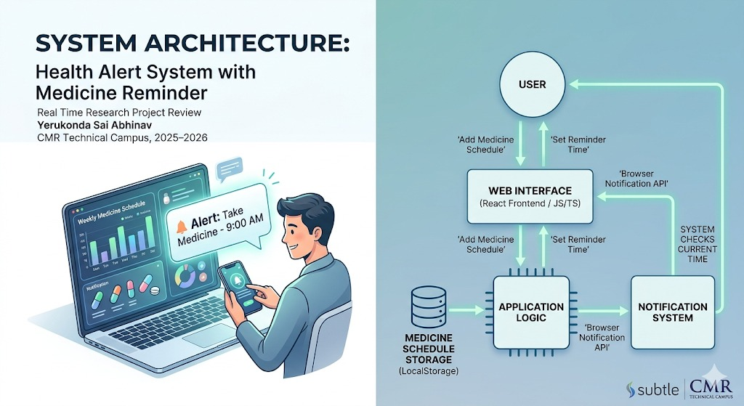
Figure 3.1 System architecture of the time aware health recommendation system

Components such as the dashboard, medication manager, schedule viewer, and profile settings form the core of the user interface. Each component handles a specific function and communicates with other components when necessary. The interface is designed to be simple and intuitive so that users can easily navigate through the application without technical difficulty. By separating the interface from the underlying logic, the architecture ensures that the visual design and functional operations of the system can be modified independently. This layered structure allows developers to enhance or modify individual modules without affecting the entire application.

The application logic layer acts as the core processing unit of the system where the main operations and data handling processes take place. This layer manages tasks such as adding new medications, updating schedules, retrieving stored medication details, and processing user inputs. It ensures that all operations performed by the user are validated and executed correctly. State management plays an important role in this layer by maintaining consistency across the application whenever data is updated. For example, when a user adds a new medicine or modifies an existing schedule, the system immediately updates the relevant components so that the changes are reflected throughout the interface.

The application logic layer also organizes the flow of information between different modules and ensures that the data remains structured and accessible. In addition, this layer includes configuration settings and control mechanisms that allow users to customize application preferences such as reminders or profile details. By handling data processing and application workflows separately from the user interface, the architecture ensures better code organization and improves the reliability of the system.
The service and integration layer is responsible for connecting the application with external services and managing additional functionalities such as intelligent assistance and data backup.

This layer includes API integrations that allow the system to communicate with external platforms, such as AI-based services for providing medication-related information and guidance. For instance, the integration of APIs like Gemini enables the application to deliver intelligent responses and assist users with queries about medicines or health-related topics. This layer also handles environment configurations, ensuring that sensitive data such as API keys are stored securely using environment variables. Additionally, it manages interactions with data storage and backup mechanisms to ensure that user information is preserved safely.

The service layer provides flexibility for future expansions, allowing developers to integrate additional healthcare services or analytical tools without major changes to the existing architecture. By separating external integrations from the main application logic, the system architecture maintains security, flexibility, and scalability. Overall, this architecture supports the smooth functioning of the Medicine Intake Project while allowing continuous improvements and feature enhancements in the future.

UML DIAGRAMS
The Unified Modeling Language (UML) diagrams are used in the Medicine Intake System to visually represent the structure and behavior of the application. These diagrams help in understanding how different components of the system interact with each other and ensure proper system design before implementation. The Use Case Diagram illustrates the interactions between the user and the system, such as adding medicines, setting reminders, and viewing schedules. The Class Diagram represents the system’s structure by defining classes like User, Medicine, and Reminder along with their attributes and relationships. The Sequence Diagram explains the step-by-step interaction between the user interface, backend, and database during operations like adding a medicine or triggering a reminder. The Activity Diagram shows the workflow of processes, including login, medicine management, and notification handling. Overall, UML diagrams improve clarity, reduce complexity, and provide a clear blueprint for developing an efficient and reliable medicine reminder system.

USE CASE DIAGRAM
The Use Case Diagram of the Medicine Intake System represents the interaction between the user and the system, highlighting the main functionalities provided by the application. In this system, the primary actor is the user (patient), who performs actions such as registering or logging into the system, adding medicine details, setting reminders, viewing scheduled medicines, and marking medicines as taken. The diagram also includes optional functionalities like updating or deleting medicine records and managing settings. Each use case defines a specific function of the system, showing what the system does from the user’s perspective. The Use Case Diagram helps in identifying system requirements clearly and ensures that all user interactions are properly handled. It provides a high-level overview of the system, making it easier for developers and stakeholders to understand the scope and functionality of the medicine reminder application.

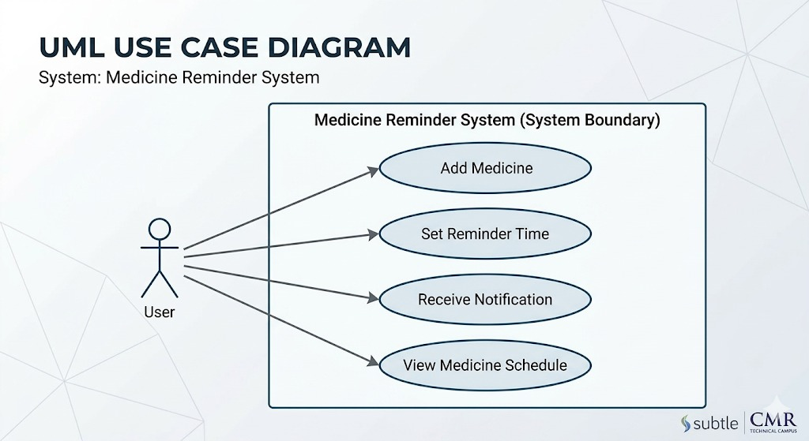
Figure 3.2 Use case diagram for time aware health recommendation system

ACTIVITY FLOW DIAGRAM
The UML Activity Diagram for the Medicine Intake System represents the workflow of the system, showing the sequence of activities involved in managing medicines and reminders. The process begins with the user logging into the system, followed by actions such as adding medicine details, setting dosage and timing, and saving the information. Once the data is stored, the system continuously monitors the scheduled time and triggers reminder notifications when required. The user then receives the notification and can choose to mark the medicine as taken or skip it. Decision nodes are used in the diagram to represent conditions, such as whether the reminder time has been reached or whether the user has taken the medicine. The flow continues until all scheduled activities are completed. This diagram helps in clearly understanding the step-by-step execution of the system and ensures that all processes are logically connected and efficiently handled.

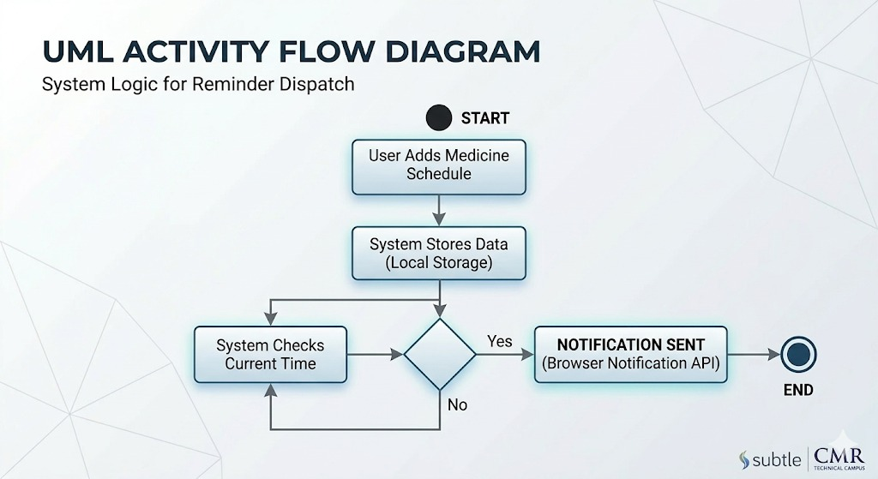

Figure 3.3 Activity flow diagram for time aware health recommendation system

MODULES

USER INTERFACE MODULE

The User Interface (UI) Module is responsible for providing an interactive and user-friendly platform through which users can access all functionalities of the medicine intake system. This module is designed with simplicity and clarity in mind so that users of all age groups, including elderly patients, can easily navigate the system.
The UI includes screens such as login/registration, dashboard, add medicine form, and reminder views. The dashboard typically displays the list of medicines along with their scheduled timings and status (taken/missed). Forms are provided for adding new medicines, editing existing entries, and deleting records. Input validation is implemented to ensure that users enter correct data such as dosage, time, and frequency.
The interface communicates with the backend using APIs (for example, Flask APIs), enabling dynamic data fetching and updating without reloading the entire application. Additionally, responsive design principles are used so that the application works smoothly across devices like mobile phones, tablets, and desktops. Overall, this module ensures a seamless interaction between the user and the system.

MEDICINE MANAGMENT MODULE

The Medicine Management Module is the core component of the system that handles all operations related to medicine data. It allows users to add, update, delete, and view medicines along with their details such as name, dosage, frequency, start date, and end date.
When a user adds a medicine, the system stores the data in a database (such as MongoDB or SQLite). Each medicine entry is associated with specific intake schedules, which are later used by the reminder module. The module ensures data consistency by validating inputs and preventing duplicate or invalid entries.
It also supports features like:
- Categorizing medicines (e.g., morning, afternoon, night)
- Tracking medicine history
- Marking medicines as taken or missed
The module interacts closely with both the UI and reminder system. Whenever a change is made (like updating dosage or time), the updated data is immediately reflected in the reminders. This ensures that the system always works with accurate and up-to-date information.

REMINDER NOTIFICATION MODULE

The Reminder Notification Module is responsible for ensuring that users take their medicines on time. It works by continuously monitoring the schedule of each medicine and triggering notifications at the appropriate times.
This module uses scheduling techniques such as timers, background services, or cron jobs (depending on implementation). When the scheduled time is reached, the system generates a notification alert, which may include:
- Medicine name
- Dosage
- Time
- Instructions (if any)
Notifications can be delivered in different forms such as:
- Push notifications (mobile apps)
- Email alerts
- System alerts (web-based popups)
The module also allows users to mark whether they have taken the medicine or skipped it. This information is stored for tracking adherence. Advanced implementations may include snooze options or repeated alerts until the medicine is marked as taken.
This module plays a crucial role in improving medication adherence and ensuring better health outcomes

SETTINGS MODULE

The Settings Module provides customization options that allow users to personalize the application according to their preferences. It enhances usability by giving users control over how the system behaves.
Typical features in this module include:
- Managing user profile details (name, email, password)
- Configuring notification preferences (sound, vibration, frequency)
- Setting reminder intervals or snooze durations
- Choosing time formats (12-hour / 24-hour)
- Enabling or disabling specific features
Security-related settings such as password change and authentication preferences are also handled in this module. In some implementations, users can also set backup or sync options to store their data securely in the cloud.
The settings module ensures flexibility and adaptability of the system, making it suitable for different user needs and preferences.

METHODOLOGY

The methodology of the Medicine Intake Project follows a structured development process that focuses on designing, implementing, and deploying a user-friendly medication management system. The development begins with requirement analysis, where the primary needs of the system are identified, such as managing medication schedules, storing medicine information, and providing an organized interface for users to track their intake. During this phase, the problems faced by patients in remembering and managing medicines are studied in order to design a system that effectively addresses those challenges. After gathering the requirements, the system design phase is carried out, where the overall architecture, modules, and workflows of the application are planned.

The system is divided into multiple functional components such as the dashboard, medication manager, schedule module, profile management, and settings. Each module is designed to perform a specific task while maintaining communication with other components of the system. The project adopts a component-based design approach using modern web technologies, which allows the application to be developed in a modular and scalable manner. This methodology ensures that the system remains flexible, maintainable, and easy to expand with additional features in the future. Proper planning and structured development help in creating an efficient system that meets the objectives of improving medication tracking and healthcare management.

After the system design phase, the implementation stage is carried out where the planned modules are developed and integrated into a complete working application. The front-end of the system is developed using React and TypeScript, which provide a responsive and interactive user interface. These technologies allow developers to create reusable components that simplify the development process and improve code maintainability. Each component is responsible for handling a specific functionality such as displaying medication information, managing schedules, or updating user profiles.

The application logic is implemented to process user inputs, manage medication records, and ensure that the system responds accurately to user actions. State management techniques are used to maintain data consistency across different components of the application. Additionally, the system integrates external services through APIs to enhance the functionality of the application. For example, AI-based services can be used to provide information about medicines or assist users with medication-related queries. The implementation process also involves configuring environment settings, installing necessary dependencies, and organizing project files in a structured manner. This systematic development process ensures that all modules function correctly and work together as a unified system.

The final stage of the methodology involves testing, deployment, and continuous improvement of the system. Testing is performed to ensure that each component of the application operates correctly and that the overall system functions as expected. Different types of testing such as functional testing, usability testing, and integration testing are conducted to identify and fix potential errors. Functional testing verifies that features like adding medicines, updating schedules, and managing profiles work properly. Usability testing ensures that the application interface is easy to understand and accessible for users with different levels of technical knowledge.

After successful testing, the system is prepared for deployment in a development environment where it can be accessed and evaluated. The application can be run locally using development tools such as Node.js and modern build tools, allowing developers to install dependencies and start the application efficiently. Continuous monitoring and feedback help developers identify areas where improvements can be made. This methodology ensures that the system evolves over time by incorporating new features, improving performance, and enhancing user experience. Overall, the structured methodology followed in the project helps in developing a reliable, efficient, and scalable medication management system.

DATASET DESCRIPTION

The dataset used in the Medicine Intake Project primarily consists of user-generated medication information that is stored and managed within the application. Unlike traditional machine learning systems that rely on large pre-collected datasets, this project focuses on dynamic data that is created and updated by users while interacting with the system. The dataset includes various types of information related to medications and user profiles, which are essential for organizing and managing medication schedules effectively. Each record in the dataset typically contains attributes such as the medicine name, dosage amount, intake frequency, timing, and duration of treatment.
These details allow the system to track the user’s medication routine and display the appropriate schedule on the dashboard. In addition to medication-related information, the dataset may also include user profile data such as name, preferences, and personalized settings that influence how the system displays reminders or schedules. By structuring this information in an organized format, the application ensures that all medication records can be easily accessed, modified, or deleted when necessary. This dataset plays a crucial role in enabling the system to provide accurate medication tracking and schedule visualization for users.
Another important aspect of the dataset is its structured storage and management within the application’s data handling system.

The dataset is typically organized in structured objects or records that are managed through the application’s state management and data processing modules. Each medication entry is stored as an individual record containing multiple fields that represent specific details about the medicine. These records are then processed by the application logic to generate medication schedules, update dashboards, and maintain accurate intake histories. The dataset may also include information about medication timing, such as morning, afternoon, evening, or specific time intervals, which helps the system generate a clear and organized medication timetable.

In addition, the application may store historical data related to previously taken medicines, allowing users to review past medication routines when needed. The structured organization of the dataset ensures that all data can be efficiently retrieved and updated without affecting other components of the system. Proper data management is essential for maintaining the reliability and performance of the application, especially when multiple medications and schedules need to be handled simultaneously.
Furthermore, the dataset is designed to support future enhancements and intelligent features within the application. Since the system integrates modern technologies and external APIs, the stored medication data can potentially be used to provide additional insights and assistance to users. For example, the dataset can be analyzed to identify patterns in medication intake or to generate helpful reminders based on user behavior. The information stored in the dataset can also be used to provide AI-based responses to medication-related queries, helping users better understand their prescriptions.

Additionally, the dataset structure allows for easy expansion, enabling developers to add new fields such as medication categories, side effects, prescription details, or doctor information in the future. Data security and privacy are also considered important aspects of the dataset design, ensuring that personal health information is handled responsibly. By maintaining an organized and flexible dataset structure, the system ensures that medication information can be efficiently managed while supporting future technological improvements. Overall, the dataset forms the foundation of the Medicine Intake Project, enabling the application to deliver reliable medication tracking and healthcare management features.

IMPLEMENTATION

ALGORITHMS USED

The Medicine Intake Project primarily relies on structured application logic and scheduling algorithms to manage and organize medication intake information efficiently. One of the main algorithmic approaches used in the system is a scheduling and sorting mechanism that organizes medications based on their intake time and frequency. When a user enters medication details such as the medicine name, dosage, and time of intake, the system processes this data and arranges it into a structured schedule. This scheduling process ensures that medicines are displayed in chronological order so that users can clearly view which medication needs to be taken at a particular time of the day.

The algorithm works by comparing medication times and placing them in the appropriate order within the user’s daily schedule. If multiple medicines are scheduled at different times, the system dynamically updates the display to show them in a sequential manner. This approach helps users easily track their upcoming medication intake and reduces confusion when managing multiple prescriptions. By applying basic sorting and scheduling algorithms, the system ensures that medication information is presented in a clear and organized format. These algorithms form the foundation of the application’s medication tracking feature, allowing the system to efficiently manage multiple medication entries and schedules.

Another important algorithmic component used in the project involves data management and state synchronization algorithms that maintain consistency across the application. Since the system is built using a component-based architecture, different parts of the application need to access and update medication data simultaneously. To handle this, the system uses state management techniques that follow structured data update mechanisms.

Whenever a user adds a new medication, edits an existing record, or deletes a medication entry, the system updates the centralized dataset and automatically reflects these changes in all relevant components such as the dashboard, medication list, and schedule view. This process involves algorithms that track changes in the dataset and trigger updates in the user interface. These algorithms ensure that all components remain synchronized and display accurate information at all times. Additionally, validation algorithms are used to verify user inputs before they are stored in the dataset. For example, the system checks whether required fields such as medication name, dosage, and time are correctly entered before saving the record. This helps prevent incomplete or incorrect data from being stored in the system. Through these data handling and synchronization algorithms, the application maintains reliability and consistency in medication tracking.

The project may also incorporate intelligent algorithms through the integration of external AI-based services to enhance the functionality of the application. By connecting to APIs that provide artificial intelligence capabilities, the system can process user queries and provide relevant information related to medications. These algorithms can analyze the user’s request, interpret the query, and generate appropriate responses that help users better understand their prescriptions. For instance, if a user asks about a particular medicine or its usage, the AI system processes the input and retrieves useful information through its knowledge base.

Additionally, intelligent algorithms can analyze stored medication data to provide helpful suggestions or reminders to users. These algorithms may detect patterns in medication intake or identify missed doses and offer notifications or guidance to improve adherence. The integration of such intelligent algorithms transforms the application from a simple medication tracker into a more advanced healthcare support system. By combining scheduling algorithms, data synchronization mechanisms, and AI-based processing techniques, the system ensures efficient medication management while also providing intelligent assistance to users. This combination of algorithms improves both the functionality and user experience of the Medicine Intake Project.

IMPLEMENTATION

The implementation of the Medicine Intake Project focuses on developing a structured and user-friendly application that helps users manage their medication schedules effectively. The development process begins with setting up the project environment using modern web development tools and frameworks. The application is built using technologies such as React and TypeScript, which allow developers to create dynamic and interactive user interfaces. These technologies support component-based development, where the application is divided into smaller reusable components such as the dashboard, medication manager, schedule viewer, profile settings, and configuration modules. Each component is designed to handle a specific function within the application, making the system more organized and easier to maintain.

During the implementation stage, the project structure is carefully organized into directories that separate user interface components, services, configuration files, and utility functions. This organized structure helps developers understand the workflow of the application and ensures that the codebase remains manageable as the project grows. The user interface is designed to provide a clean and intuitive experience, allowing users to easily add medications, view schedules, and manage their personal settings without complexity.

The core functionality of the system is implemented through application logic that manages medication data and user interactions. When a user enters details about a medicine, such as its name, dosage, and intake time, the system processes this information and stores it in the application’s data structure. The stored data is then used to generate a medication schedule that is displayed on the dashboard and other relevant sections of the application. The implementation ensures that any updates made by the user, such as modifying medication details or deleting an entry, are immediately reflected throughout the application.

This is achieved through state management techniques that maintain consistency between different components. Input validation mechanisms are also implemented to ensure that users provide accurate and complete information before the data is stored. For example, the system checks whether essential fields are filled correctly and prevents incomplete records from being saved. The implementation also includes interactive features such as navigation menus, buttons, and forms that allow users to move easily between different modules of the application. These elements work together to create a smooth and responsive user experience.

Another important part of the implementation is the integration of external services and configuration settings that enhance the functionality of the application. The system is designed to connect with external APIs, such as AI-based services, to provide additional support and information related to medications. These integrations are implemented through service modules that handle communication between the application and external platforms. To maintain security, sensitive information such as API keys is stored in environment configuration files rather than directly within the application code.

The implementation also includes configuration files and dependency management systems that allow developers to install required libraries and run the application efficiently. Once the development phase is completed, the system can be tested locally using development tools and runtime environments such as Node.js. This allows developers to identify and resolve potential issues before deployment. The modular implementation approach ensures that the system remains flexible and can be easily expanded with new features such as reminder notifications, health analytics, or integration with other healthcare services in the future. Overall, the implementation process transforms the conceptual design of the Medicine Intake Project into a functional and reliable application that supports effective medication management.

Sample Code: -

import React, { useState, useEffect, useCallback, useMemo } from 'react';
import { AppState, UserProfile, Medication, Reminder, HealthInsight } from './types';
import { loadState, saveState } from './store';
import { getHealthInsights } from './geminiService';

// Pages
import Dashboard from './components/Dashboard';
import MedicationManager from './components/MedicationManager';
import Schedule from './components/Schedule';
import ProfileSetup from './components/ProfileSetup';
import Settings from './components/Settings';
import Backup from './components/Backup';

// Components
import BottomNav from './components/BottomNav';
import Header from './components/Header';

const App: React.FC = () => {
const [state, setState] = useState<AppState>(loadState());
const [currentPage, setCurrentPage] = useState<string>('dashboard');
const [insights, setInsights] = useState<HealthInsight[]>([]);
const [loadingInsights, setLoadingInsights] = useState(false);

// Persistence effect
useEffect(() => {
saveState(state);
}, [state]);

// Insights effect
useEffect(() => {
if (state.profile.setupComplete) {
setLoadingInsights(true);
getHealthInsights(state).then(res => {
setInsights(res);
setLoadingInsights(false);
});
}
}, [state.profile.setupComplete, state.waterIntake]);

const updateProfile = (profile: UserProfile) => {
setState(prev => ({ ...prev, profile }));
};

const addMedication = (med: Medication) => {
setState(prev => ({ ...prev, medications: [...prev.medications, med] }));
};

const deleteMedication = (id: string) => {
setState(prev => ({ ...prev, medications: prev.medications.filter(m => m.id !== id) }));
};

const updateMedication = (med: Medication) => {
setState(prev => ({
...prev,
medications: prev.medications.map(m => (m.id === med.id ? med : m))
}));
};

const toggleMedicationTaken = (id: string, timing: string) => {
setState(prev => {
const medications = prev.medications.map(m => {
if (m.id === id) {
const takenToday = m.takenToday || [];
if (takenToday.includes(timing)) {
return { ...m, takenToday: takenToday.filter(t => t !== timing) };
} else {
return { ...m, takenToday: [...takenToday, timing] };
}
}
return m;
});
return { ...prev, medications };
});
};

const updateWater = (delta: number) => {
setState(prev => ({ ...prev, waterIntake: Math.max(0, prev.waterIntake + delta) }));
};

const importState = (newState: AppState) => {
setState(newState);
window.location.reload();
};

if (!state.profile.setupComplete && currentPage !== 'profile') {
return <ProfileSetup onComplete={(p) => { updateProfile(p); setCurrentPage('dashboard'); }} initialProfile={state.profile} />;
}

const renderPage = () => {
switch (currentPage) {
case 'dashboard':
return <Dashboard state={state} updateWater={updateWater} toggleMed={toggleMedicationTaken} insights={insights} loadingInsights={loadingInsights} />;
case 'medications':
return <MedicationManager medications={state.medications} onAdd={addMedication} onDelete={deleteMedication} onUpdate={updateMedication} />;
case 'schedule':
return <Schedule state={state} toggleMed={toggleMedicationTaken} />;
case 'settings':
return <Settings profile={state.profile} updateProfile={updateProfile} />;
case 'backup':
return <Backup state={state} onImport={importState} />;
case 'profile':
return <ProfileSetup onComplete={(p) => { updateProfile(p); setCurrentPage('settings'); }} initialProfile={state.profile} isEdit />;
default:
return <Dashboard state={state} updateWater={updateWater} toggleMed={toggleMedicationTaken} insights={insights} loadingInsights={loadingInsights} />;
}
};

return (
<div className="flex flex-col min-h-screen pb-20">
<Header profile={state.profile} onProfileClick={() => setCurrentPage('profile')} />
<main className="flex-1 max-w-4xl mx-auto w-full px-4 py-6">
{renderPage()}
</main>
<BottomNav active={currentPage} onNavigate={setCurrentPage} />
</div>
);
};

export default App;

import React from 'react';
import ReactDOM from 'react-dom/client';
import App from './App';

const rootElement = document.getElementById('root');
if (!rootElement) {
throw new Error("Could not find root element to mount to");
}

const root = ReactDOM.createRoot(rootElement);
root.render(
<React.StrictMode>
<App />
</React.StrictMode>
);

export type Gender = 'male' | 'female' | 'non-binary' | 'prefer-not-to-say' | '';

export interface UserProfile {
name: string;
dob: string;
gender: Gender;
height: number;
weight: number;
healthIssues: string;
setupComplete: boolean;
}

export type MedicationTiming = 'morning' | 'afternoon' | 'night' | 'custom';
export type MedicationInstruction = 'before-food' | 'after-food' | 'none';

export interface Medication {
id: string;
name: string;
dosage: string;
timings: MedicationTiming[];
customTime?: string;
startDate: string;
endDate: string;
instruction: MedicationInstruction;
notes: string;
takenToday?: string[]; // list of times taken today like ["morning", "night"]
}

export interface Reminder {
id: string;
title: string;
type: 'medicine' | 'water' | 'food' | 'exercise' | 'custom';
time: string;
days: number[]; // 0-6 (Sun-Sat)
active: boolean;
}

// Added HealthInsight interface to be shared between service and UI components
export interface HealthInsight {
title: string;
description: string;
type: 'info' | 'warning' | 'success';
}

export interface AppState {
profile: UserProfile;
medications: Medication[];
reminders: Reminder[];
waterIntake: number; // glasses taken today
waterGoal: number;
lastUpdated: string;
}

GEMINI_API_KEY=PLACEHOLDER_API_KEY

{

RESULTS AND DISCUSSION

EXPERIMENTAL RESULTS

The experimental results of the Medicine Intake Project focus on evaluating the functionality, usability, and performance of the developed application. After completing the implementation phase, the system was tested under different scenarios to ensure that all modules operate correctly and efficiently. The primary objective of the testing process was to verify whether the application successfully supports medication management tasks such as adding medicines, updating schedules, viewing medication lists, and managing user settings.

During the testing phase, multiple medication entries were added to the system to evaluate how the application organizes and displays medication schedules on the dashboard. The results showed that the system correctly stored medication details such as medicine name, dosage, intake time, and frequency. The scheduling component was able to arrange medicines based on their intake time, allowing users to clearly view which medicines needed to be taken during different parts of the day. The user interface responded accurately to user interactions, and changes made to medication records were immediately reflected across the application. These results indicate that the application effectively manages medication data and presents it in an organized and user-friendly manner. The successful execution of these tests confirms that the core functionalities of the system operate as expected.

Another set of experimental evaluations focused on the usability and responsiveness of the application interface. Usability testing was conducted to determine how easily users could interact with the system and perform basic tasks such as adding a new medicine, editing medication details, and navigating between different sections of the application. The results demonstrated that the interface is intuitive and easy to understand, even for users with limited technical knowledge. The component-based design allowed the application to maintain a consistent layout across different modules, improving the overall user experience.

The dashboard provided a clear overview of medication schedules, enabling users to quickly identify their upcoming doses. Additionally, the application responded quickly to user actions such as submitting forms or switching between modules, which indicates that the system is capable of handling real-time updates efficiently. The testing results also showed that the system maintained data consistency when multiple updates were made, ensuring that medication records remained accurate and up to date. These findings highlight the effectiveness of the system’s design in providing a smooth and reliable user experience.

The experimental results also examined the integration of external services and the system’s ability to support intelligent features. The integration with external APIs, such as AI-based services, was tested to ensure that the application could successfully communicate with external platforms and retrieve relevant information when required. The results indicated that the API integration worked effectively, allowing the system to process user queries and provide helpful responses related to medication information.

This feature enhances the overall functionality of the application by offering additional support to users who may need guidance about their prescriptions. Furthermore, the system demonstrated stable performance during testing, with no major errors or failures observed during the execution of different modules. The structured architecture of the application allowed each component to operate independently while still maintaining smooth communication with other parts of the system. These experimental results confirm that the Medicine Intake Project successfully fulfills its objective of providing a reliable and efficient medication management platform. The system’s performance, usability, and intelligent features demonstrate its potential to support users in managing their medication routines effectively.

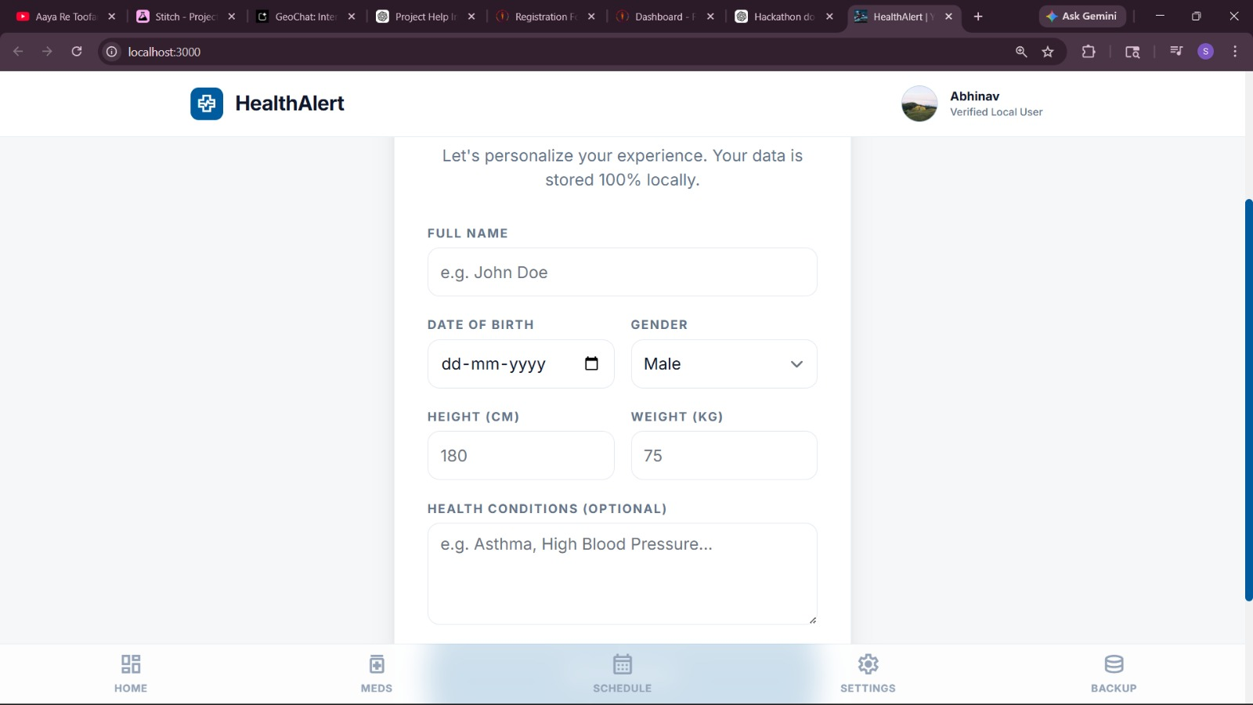
Figure 5.1 User login page

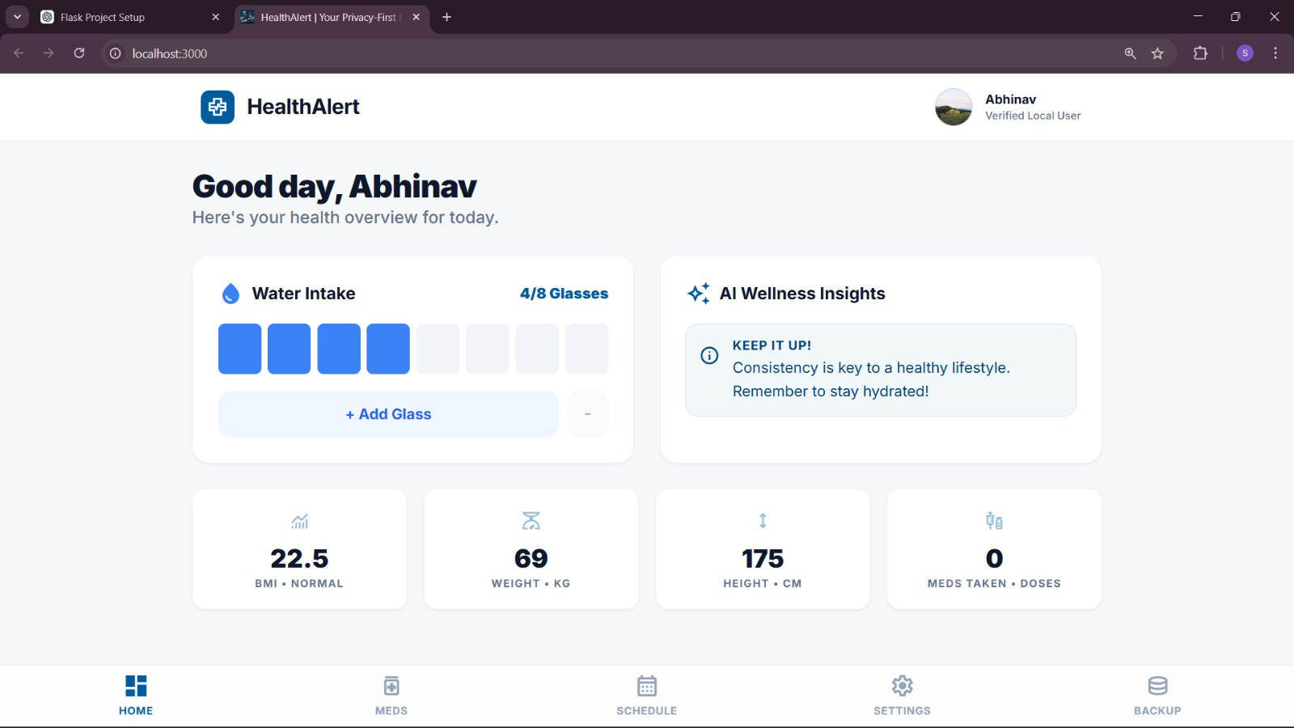
Figure 5.2 User Home page

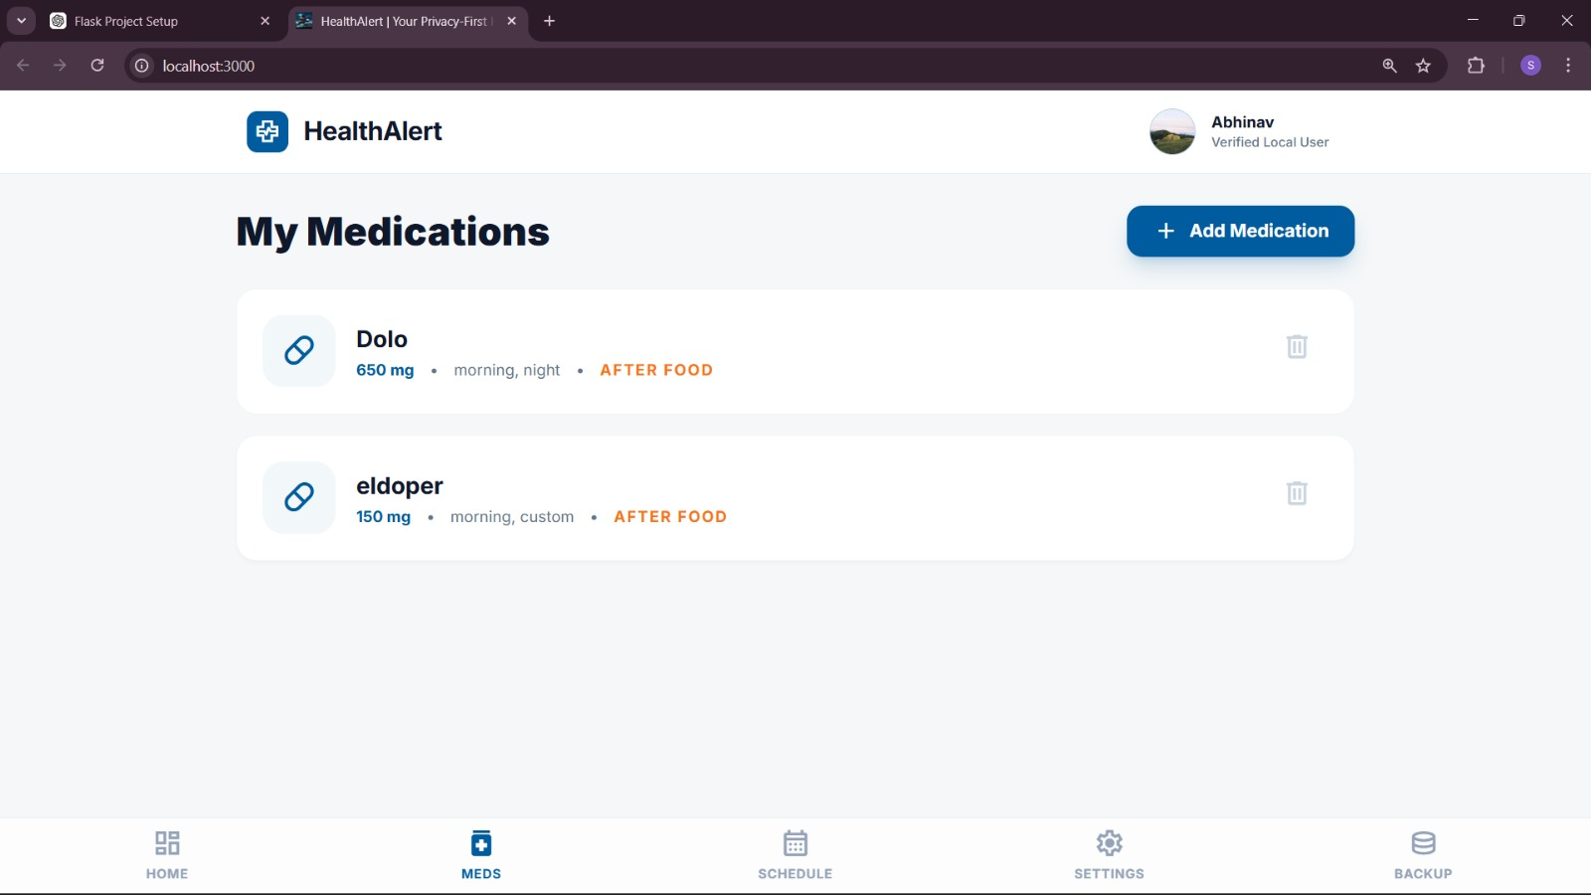
Figure 5.3 User added medications page

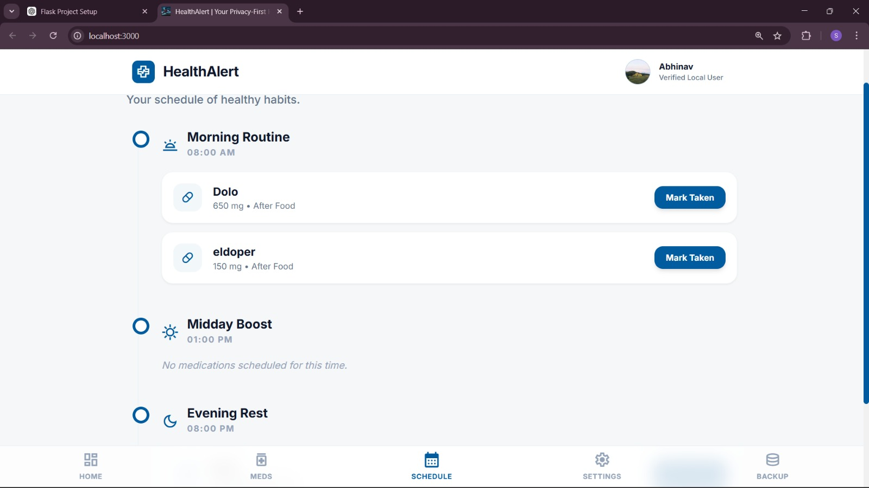
Figure 5.4 User schedule page

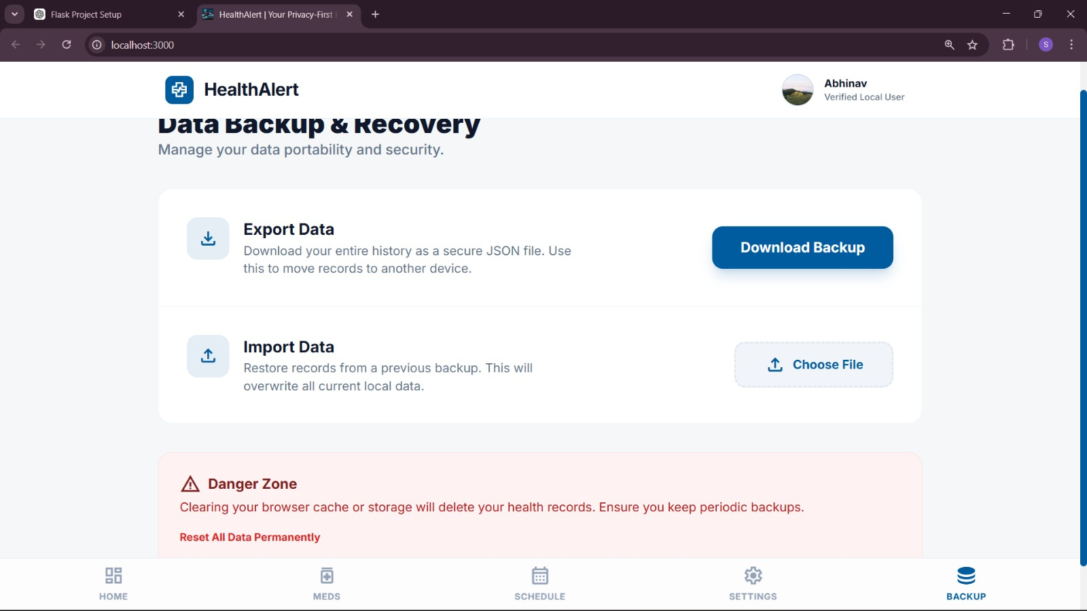
Figure 5.5 Backup and recovery page

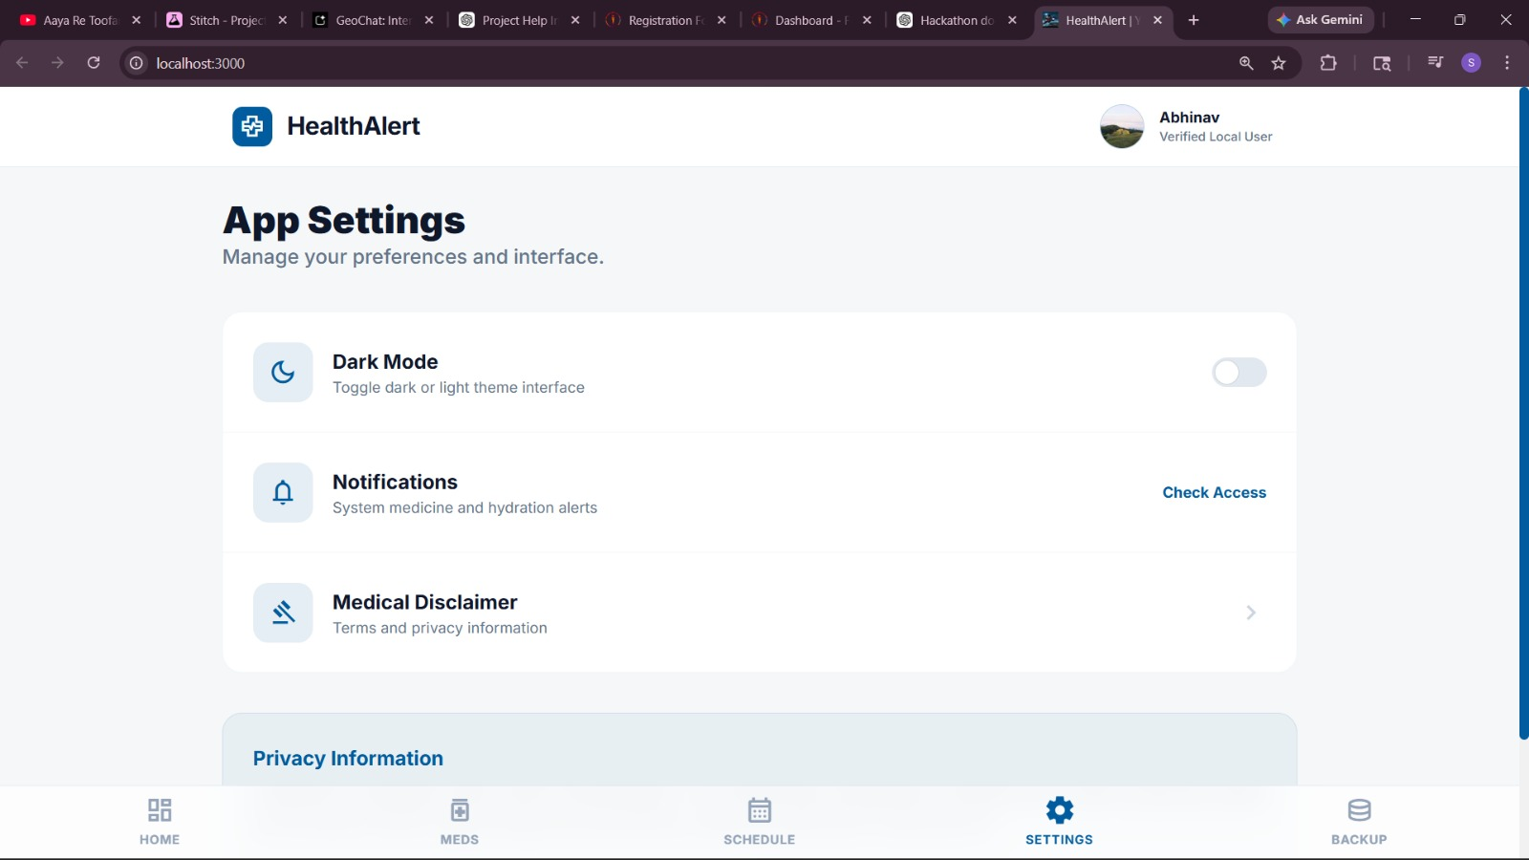
Figure 5.6 Application settings

VALIDATION

VALIDATION
Validation in the Medicine Intake System ensures that the data entered by the user is accurate, complete, and reliable before it is processed or stored in the database. It is implemented at both the frontend and backend levels to prevent invalid or incorrect inputs. For example, while adding a medicine, the system checks whether all required fields such as medicine name, dosage, and time are filled correctly. It also verifies that time values are in the correct format and that dosage values are within a valid range. Input fields are validated to avoid empty entries, duplicate records, or incorrect data types. Additionally, user authentication details such as email and password are validated to ensure proper login security. If any invalid data is detected, appropriate error messages are displayed to guide the user. Overall, validation improves data integrity, enhances system reliability, and ensures smooth functioning of the medicine reminder application.

CONCLUSION

CONCLUSION

The Medicine Intake Project presents an effective digital solution for managing medication schedules and improving adherence to prescribed treatments. Many individuals struggle to maintain consistent medication routines due to busy lifestyles, complex prescriptions, or simple forgetfulness. This project addresses these challenges by providing a structured platform where users can store, organize, and monitor their medication information in a convenient and accessible way.

Through features such as medication management, scheduling modules, and an interactive dashboard, the system allows users to clearly track their medicine intake and maintain accurate records. The use of modern web technologies such as React and TypeScript enables the application to provide a responsive and user-friendly interface that enhances the overall user experience. By digitizing the medication management process, the project helps reduce the chances of missed doses and promotes more responsible healthcare practices. The system demonstrates how technology can play an important role in simplifying everyday health-related tasks and supporting individuals in maintaining better control over their treatment routines.

Another important outcome of the project is the implementation of a modular and scalable system architecture that allows for easy expansion and future development. The application is designed using a component-based structure, where each module performs a specific function while working together as part of a unified system. This approach ensures that the system remains organized, maintainable, and adaptable to future technological advancements.

Features such as profile management, data handling, and integration with external services contribute to the overall functionality of the application. The integration of AI-based services also opens opportunities for intelligent healthcare assistance, enabling users to receive helpful information and guidance related to medications. The system’s ability to handle medication data efficiently and present it in a structured format demonstrates the effectiveness of the implemented algorithms and design methodology. Through careful planning, development, and testing, the project successfully achieves its objective of creating a reliable medication management platform. These results highlight the potential of digital healthcare systems in improving patient engagement and supporting better treatment adherence.

In conclusion, the Medicine Intake Project serves as a valuable example of how modern technology can be used to address real-world healthcare challenges. The system provides users with a practical tool for managing medication schedules, reducing errors in medicine intake, and improving awareness of their treatment routines. While the project already includes several useful features, it also provides a strong foundation for future enhancements such as automated reminders, wearable device integration, and advanced health analytics.

These potential improvements can further increase the effectiveness and usefulness of the system. Additionally, the project demonstrates the importance of combining good software design principles with healthcare-oriented functionalities to create applications that are both reliable and user-friendly. As digital healthcare solutions continue to evolve, systems like the Medicine Intake Project can play a significant role in promoting better patient care and self-management. Overall, the project successfully demonstrates the benefits of integrating technology with healthcare management, offering a scalable and efficient platform that supports improved medication adherence and overall health monitoring.

FUTURE WORK
The future development of the Medicine Intake Project can focus on enhancing the system with advanced features that improve medication management and overall user experience. One potential improvement is the implementation of an automated reminder and notification system that alerts users when it is time to take their medicines. These reminders can be delivered through push notifications, emails, or mobile alerts to ensure that users never miss their scheduled doses. This feature would be particularly useful for individuals who have complex medication schedules or need to take medicines multiple times a day.

Another possible enhancement is the integration of calendar-based scheduling and visual timelines that provide a clearer representation of medication routines over a day, week, or month. By incorporating these visual tools, users would be able to better understand and plan their medication intake. Additionally, future versions of the system could support multi-user functionality, allowing caregivers or family members to manage medication schedules for elderly patients or children. This would make the system more versatile and useful in household healthcare management. These improvements would significantly increase the effectiveness and practicality of the application.

Another area for future work is the deeper integration of intelligent technologies and healthcare data analysis within the application. The current system can be extended by incorporating more advanced artificial intelligence and machine learning capabilities to provide personalized medication assistance. For example, the system could analyze medication patterns and detect missed doses or irregular intake behaviors, then provide suggestions to help users improve adherence to their treatment plans. AI-based chat assistants could also be developed to answer user queries about medicines, possible side effects, and general health guidance in a more interactive way.

In addition, future development could include the integration of wearable health devices such as smartwatches or fitness trackers. These devices could automatically collect health-related data such as heart rate, sleep patterns, or activity levels and combine it with medication information to provide better health insights. The system could also generate reports that summarize medication history and health trends, which could be shared with healthcare professionals during medical consultations. These intelligent features would transform the application into a more advanced digital healthcare assistant.

Future work may also focus on improving system scalability, security, and integration with other healthcare platforms. As the application grows and supports more users, it may require stronger backend infrastructure and cloud-based data storage to handle larger volumes of data efficiently. Implementing secure authentication methods, encrypted data storage, and strict access control mechanisms will be essential for protecting sensitive personal health information. In addition, the system could be integrated with hospital management systems, pharmacy services, and electronic health record (EHR) platforms to provide a more comprehensive healthcare ecosystem.

Such integration would allow prescriptions to be automatically updated within the system, reducing the need for manual data entry by users. The application could also support multiple language options and accessibility features to make it more inclusive for users from different backgrounds and age groups. Furthermore, mobile application versions of the system could be developed to allow users to access medication information anytime and anywhere. By focusing on these improvements, the Medicine Intake Project can evolve into a more powerful, secure, and widely accessible healthcare management platform in the future.

GitHub link :

https://github.com/Manojkumar128/Time-Aware-health-recommendation-system.git

